1. What is DHTML?

The DHTML stands for “dynamic hypertext transfers markup language”. DHTML is not a language. It is basically a collection of web technologies that are used together to create robust interactive web applications. The web page’s behavior will change in response to the user’s behaviors.

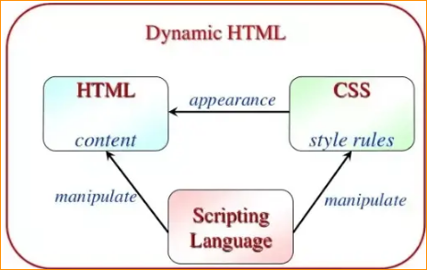

So, in simple words, we can say that DHTML is a combination of three technologies such as HTML, CSS, and JavaScript.

All three components are connected via the **Document Object Model (DOM).**

* HTML defines web sites content through semantic tags (heading, sections, articles, paragraphs, lists)
* CSS described the look and formatting of a document
* Layout and position of elements on the page
* Presentation styles (background, border, colors…)
* Text and font styles (size, color, family)
* JavaScript defines dynamic behavior
* Programming logic for interaction with the user
* Handle user events
* HTML, CSS, and JavaScript are the three layers of the Web that helps to make web pages interactive.

What can JavaScript do?

Can handle events such as button clicks

Can read/ write HTML elements and modify the DOM tree dynamically

It Can access/modify the browser cookies.

It can detect the user browser as well as the Operating System (OS) of the user.

We can also Implement the object-oriented language features using JavaScript

It is also used to make asynchronous server calls (i.e. AJAX calls)

Can implement complex graphics and animation via Canvas

It is also possible to implement back-end logic using Node.js

1. JavaScript Basic Syntax:

* JavaScript contains JavaScript statements that are placed between **the <script>… </script>** HTML tags in a web page.
* You can put the <script> tag containing JavaScript code anywhere within your web page but it is considered as the best way to keep it within the <head> tags.
* The <script> tag tells the browser to begin converting all the text between these tags as a script. In simple words is specifies that we are using JavaScript. The simple syntax of JavaScript will be as:

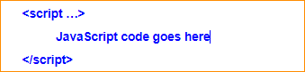

1. The Script takes 3 attributes:

* **language**: this attribute indicates which **scripting language we are using in the program** and its value will be javascript.
* **type**: this attribute **indicates the scripting language is getting used** and its value should be “text/javascript”.
* **src**: it specifies the **URL of an external JavaScript file.** This attribute overrides any existing JavaScript place between the <script>

